Nov 29, 2024
BLE Mesh based IR AC Controller
Software Design Document

Revision History

Version | Release Date | Prepared by | Remarks
0.2 | 01.04.2024 | Kulasekaran | - Draft Version
0.3 | 10.04.2024 | Kulasekaran | - Removed the Heartbeat related content as temperature data has been decided to be taken as heartbeat  - Added Teaching mode packet and ACK for Gwy and Node
0.4 | 24.04.2024 | Kulasekaran | - Changed the Temperature upper and lower limit keys
0.5 | 24.06.2024 | Kulasekaran | - Added Solid Purple indication for when sending out IR command in both Gwy and Node  - Added packet information regarding Teaching modes  - Added Boot up LED pattern information for both Gwy and Node in the LED Table  - Modified Button press logics  - Added Debug Info packets for Gwy and Node  - Changed ErrorCode values  - Minor changes with more clear descriptions to certain sections across the whole document  - Added Detailed Error Code information  - LED indication change for Teaching mode and AC Remote configuration mode.
0.6 | 30.07.2024 | Kulasekaran | - Added ResetDevice and Logging to the Error code  - Added Unsupported Remote LED indication  - Removed NODE_ALREADY_PROV error code  - Added AC_REMOTE_UNSUPPORTED error code  - The default Heartbeat interval increased from 10s to 300s.  - Added JSON_PACKET_INVALID error code
0.7 | 01.08.2024 | Kulasekaran | - ACK responses simplified. Unnecessary fields removed.  - Change to Button press logics
1.0.0 | 29.11.2024 | Kulasekaran | - Node provisioning flow modified  - Button press functionalities modified  - Error codes modified  - JSON Packet modified  - Teaching mode modified  - LED indications modified

Introduction
This Software Design Document outlines the technical architecture, design components, and implementation strategy for the project “IR BLE Mesh AC Controller”. It serves as a comprehensive guide to ensure the system aligns with the client's functional requirements, scalability goals, and performance expectations. The document details key design decisions, system interactions, and data flow, providing clarity for all stakeholders. Our approach prioritizes modularity, reliability, and adaptability to accommodate future enhancements. This document will act as a reference throughout development, ensuring consistency and traceability from design to deployment. Feedback is encouraged to confirm alignment with the client’s objectives and to address any concerns proactively.

Purpose of Document
The purpose of this Software Design Document (SDD) is to provide a detailed blueprint for the development of the project “IR BLE Mesh AC Controller”. It ensures a shared understanding of the system’s architecture, design principles, and implementation strategy among all stakeholders, including the client, development team, and QA team. The goal is to deliver a solution that aligns with the client’s objectives while adhering to industry best practices.

Scope of the Project

Definitions, Acronyms and Abbreviations
Acronym | Full Form
ACK | Acknowledgement
UART | Universal Asynchronous Receiver Transmitter

Abbreviation | Full Form
BLE | Bluetooth Low Energy
GWY | Gateway
IR | Infrared
JSON | Java Script Object Notation
LTE | Long Term Evolution
MQTT | Message Queuing Telemetry Transport

Term | Description
Registration | Adding a Gateway device
Unregistration | Removing a Gateway device
Provisioning | Adding a Node device into BLE Mesh Network
Unprovisioning | Removing a Node device from BLE Mesh Network

References

Overview of the Document structure

System Overview
The project “IR BLE Mesh AC Controller” is designed to enable seamless control and monitoring of air conditioners. The product comes in two variants: the Gateway and the Node, which work together to provide a comprehensive solution for smart AC management.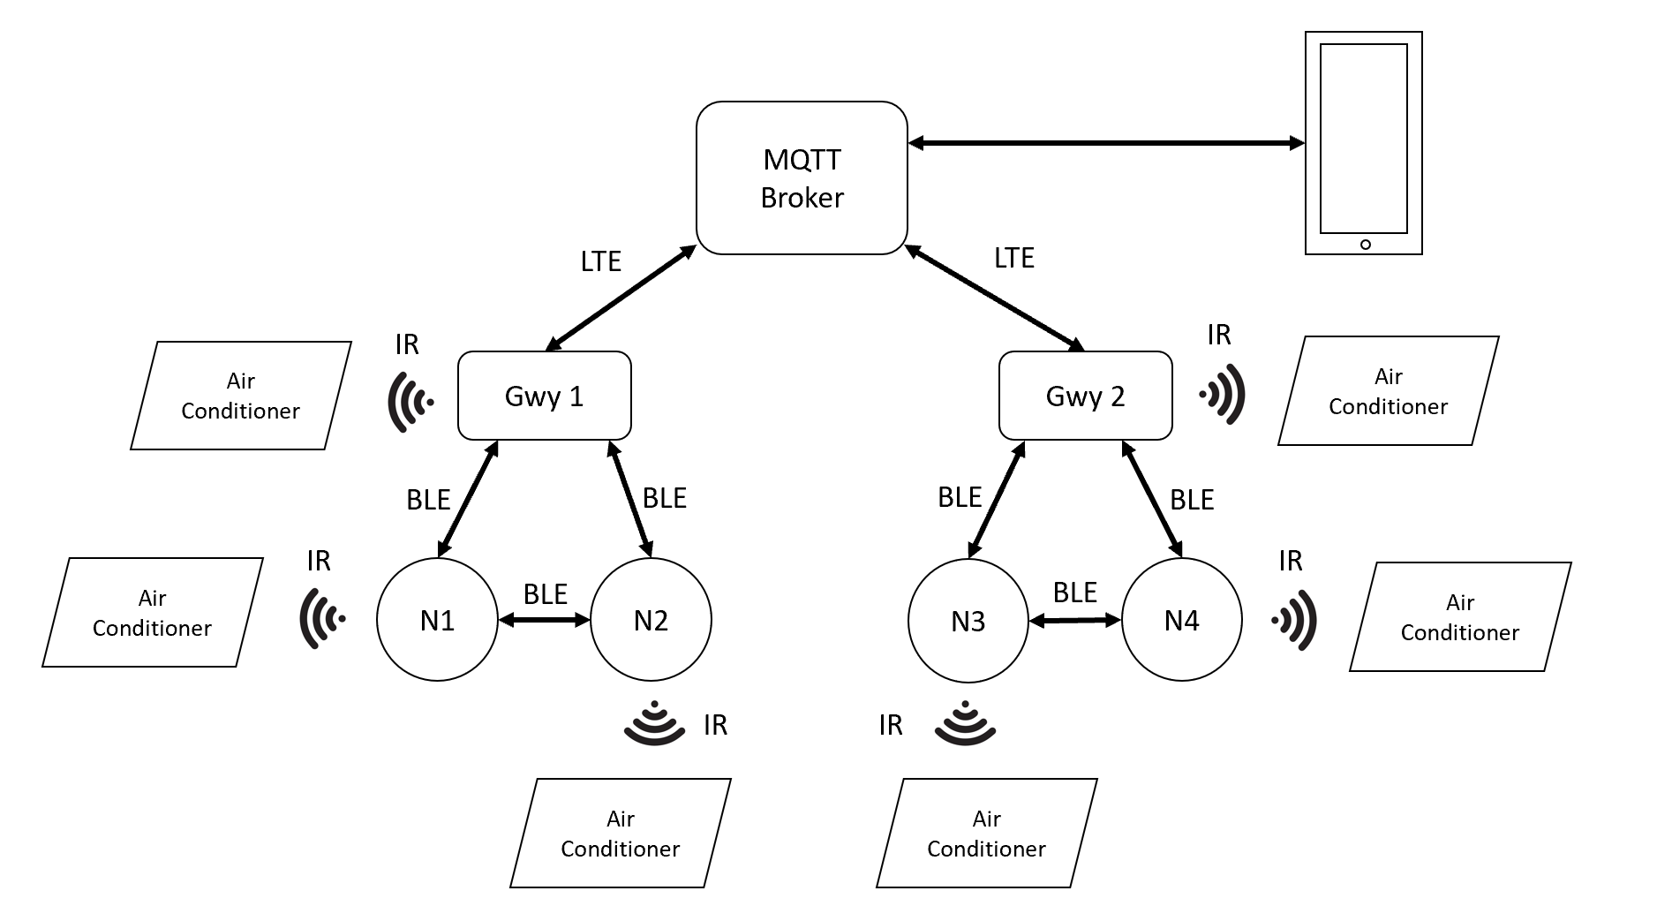

System Architecture
- Gateway (Master):
  - Equipped with LTE capability for internet connectivity.
  - Connects to an MQTT broker, enabling communication through MQTT topics.
  - Acts as the central controller of the BLE mesh network.
  - Updates the system status to the cloud and processes user commands from the mobile app via MQTT.
- Node (Slave):
  - Functions as a BLE mesh device communicating with the Gateway.
  - Executes commands relayed by the Gateway, such as adjusting AC settings or retrieving sensor data.
- Mobile App:
  - Connects to the same MQTT broker as the Gateway.
  - Allows users to send commands and receive real-time status updates from the Gateway via MQTT topics.

Key Features
- BLE Mesh Communication:
  - Establishes reliable and efficient communication between Gateway and multiple Nodes within the network.
- MQTT Integration:
  - Facilitates seamless interaction between the Gateway and the mobile app, enabling remote control and monitoring.

Use Cases
- Remote Control via Mobile App:
  - Users can adjust AC settings or query system status through MQTT-based communication with the Gateway.
- System Notifications:
  - Fault detection and system status updates are pushed to the mobile app through MQTT topics for real-time alerts.
This system integrates BLE mesh communication for local functionality with MQTT-based cloud connectivity, providing a scalable and efficient solution for modern AC management.

Architecture Design
The Architecture Design section provides a comprehensive overview of the system’s high-level structure, detailing the key components, their responsibilities, and how they interact with each other. This design ensures the system meets its functional and non-functional requirements, such as scalability, security, and performance.
The system is organized into multiple layers and modules, each serving a specific purpose:
- User Layer:
  - Mobile App: The mobile app interfaces with the system, providing users with a means to control and monitor their air conditioners. The app communicates with the Gateway via MQTT to send commands and receive real-time updates.
- Gateway Layer:
  - Gateway Device: The master unit in the system that manages communication with the Nodes via BLE Mesh and connects to the cloud via LTE for remote access. Every Gwy device is identified by its unique <GwySerNo>. This is set during flashing the Gwy device and cannot be changed later. (Eg. GWY00001)
  - MQTT Client: The Gateway connects to an MQTT broker, enabling bidirectional communication with the mobile app.
  - IR Software module: Uses a third-party IR library to decode and transmit IR signals for controlling AC units.
- Node Layer:
  - Node Device: A BLE Mesh device that acts as a slave, responsible for controlling the AC based on commands received from the Gateway. It reports status information back to the Gateway and executes local control functions when necessary. Every Gwy device is identified by its unique <NodeSerNo>. This is set during flashing the Gwy device and cannot be changed later. (Eg. N00001).
- Communication Layer:
  - BLE Mesh: Provides a robust, low-power communication network between the Gateway and Node devices. BLE Mesh ensures the scalability and reliability of communication in environments with multiple devices.
  - LTE & MQTT: The Gateway communicates with the MQTT broker over the LTE network, enabling cloud connectivity, remote status updates, and command execution.
- Cloud Layer:
  - Cloud Platform: Hosts the MQTT broker and processes the data sent by the Gateway. This layer is responsible for long-term storage, analytics, and any external interactions

Key Interactions and Data Flow
- Mobile App to MQTT Broker: The mobile app communicates with the MQTT broker to send control commands to the Gateway.
- Gateway to Nodes: The Gateway manages and controls the Nodes through BLE Mesh, sending commands and receiving status updates.
- Gateway to Cloud: The Gateway updates the cloud platform with status data, device health information, via MQTT.
- IR Control: When the Gateway sends a command to control the AC, the IR Software module translates the MQTT command into the appropriate IR signals and transmits them to the AC unit.

This architecture ensures a robust, scalable, and secure system for managing air conditioning units, providing real-time control, monitoring, and seamless integration with external cloud services. The system is designed to handle a growing number of devices, ensuring reliability and performance even as the network expands.

Limitations & Assumptions

Limitations
- Connectivity Range: The BLE mesh network’s effective range may be limited by environmental factors such as physical obstructions or interference from other wireless devices.
- Internet Connectivity: While the Gateway has LTE connectivity, the system’s remote control and status updates depend on the availability of a stable internet connection. Due to the nature of MQTT and potential delays in cloud communication, there may be minor latencies in status updates or command execution, especially during high network traffic.
- IR Library Support: The system uses a third-party IR library for decoding IR signals and transmitting AC control IR commands. As the library is still under continuous development, not all AC models will be supported. Additionally, within the same brand, different models may use different IR protocols, meaning the model is more important than the brand when ensuring compatibility.

Assumptions
- Network Stability: It is assumed that the Gateway will always have access to a reliable LTE network for remote communication and MQTT-based control.
- IR noise free environment: During initial setup and during the process of Teaching, the devices must be in an IR noise free environment.

Physical Button Functionalities
Press type | Gateway | Node
Single press | Initiate Power Cycle sequence | Initiate Power Cycle sequence
Double press | None | None
Triple press | Unregisters device | Unprovisions device
Long press (1-3s) | Enter/Exit Teaching mode | Enter/Exit Teaching mode
Long press (>3s) | Factory Reset Device | Factory Reset Device

LED Indications
Indication | Gateway | Node
Solid Red | Device not connected to MQTT | Device is Unprovisioned and non-connectable
Toggling Red and Blue | Device is Unregistered | Device in Unprovisioned and connectable
Solid Blue | Device is Unconfigured | Device is Unconfigured
Solid Green | Fully operational | Fully operational
Blinking Blue | Device in Teaching mode | Device in Teaching mode
Blinking Yellow | Device in power cycle sequence | Device in power cycle sequence
Blinking Purple | Sending out IR signal | Sending out IR signal
Blinking Red | Invalid event/command detected | Invalid event/command detected

JSON Packets
Packet ID | Packet Name
0 | Gwy Registration Packet
1 | Gwy AC Remote Configuration Packet
2 | Gwy Unregistration Packet
3 | Gwy AC Control Packet
4 | Gwy Manual AC Control ACK
5 | Gwy AC Remote Reconfiguration Packet
6 | Gwy Heartbeat ACK
7 | Gwy Heartbeat Publish Configuration Packet
8 | Gwy Teaching Mode Packet
9 | Gwy Debug Info Packet
11 | Gwy General ACK
100 | Node Provisioning Packet
101 | Node AC Remote Configuration ACK
102 | Node Unprovisioning Packet
103 | Node AC Control Packet
104 | Node Manual AC Control ACK
105 | Node AC Remote Reconfiguration Packet
106 | Node Heartbeat ACK
107 | Node Heartbeat Publish Configuration Packet
108 | Node Teaching Mode Packet
109 | Node Debug Info Packet
111 | Node General ACK

For more information about these packets, what parameters are required, the data type of values and the value range, please refer to this link. This will contain examples of these packets as well.

Error Codes
Error Code | Error Code Name
-1 | FAILURE
0 | SUCCESS
1 | JSON_PACKET_INVALID
2 | MISSING_PACKET_ID
3 | PACKET_ID_EXCEEDING_RANGE
4 | MISSING_MSG_SEQ_NO
5 | MSG_SEQ_NO_EXCEEDING_RANGE
6 | MISSING_LOCATION
7 | LOCATION_EXCEEDING_RANGE
8 | NODE_COMM_TIMEOUT
9 | GWY_NOT_REG
10 | GWY_ALREADY_REG
11 | MISSING_MACID
12 | INVALID_MACID
13 | MISSING_ELEMENT_ADDR
14 | ELEMENT_ADDR_EXCEEDING_RANGE
15 | DEVICE_NOT_CONFIGURED_WITH_AC_REMOTE
16 | MISSING_POWER
17 | POWER_EXCEEDING_RANGE
18 | MISSING_MODE
19 | MODE_EXCEEDING_RANGE
20 | MISSING_FAN_SPEED
21 | FAN_SPEED_EXCEEDING_RANGE
22 | MISSING_TEMPERATURE
23 | TEMPERATURE_EXCEEDING_RANGE
24 | MISSING_SWINGH
25 | SWINGH_EXCEEDING_RANGE
26 | MISSING_SWINGV
27 | SWINGV_EXCEEDING_RANGE
28 | MISSING_ONTIMER
29 | ONTIMER_EXCEEDING_RANGE
30 | MISSING_OFFTIMER
31 | OFFTIMER_EXCEEDING_RANGE
32 | MISSING_LOCKING
33 | LOCKING_EXCEEDING_RANGE
34 | MISSING_TEMPERATURE_UPPER_LIMIT
35 | TEMPERATURE_UPPER_LIMIT_EXCEEDING_RANGE
36 | MISSING_TEMPERATURE_LOWER_LIMIT
37 | TEMPERATURE_LOWER_LIMIT_EXCEEDING_RANGE
38 | INVALID_TEMPERATURE_LOCKING_LIMITS
39 | MISSING_PUBLISH_PERIOD
40 | PUBLISH_PERIOD_EXCEEDING_RANGE
41 | MISSING_RESET_DEVICE
42 | RESET_DEVICE_EXCEEDING_RANGE
43 | MISSING_LOGGING
44 | LOGGING_EXCEEDING_RANGE
45 | AC_REMOTE_UNSUPPORTED
46 | MISSING_TEACHING_START
47 | TEACHING_START_EXCEEDING_RANGE
48 | MISSING_STARTING_TEMPERATURE
49 | STARTING_TEMPERATURE_EXCEEDING_RANGE
50 | MISSING_ENDING_TEMPERATURE
51 | ENDING_TEMPERATURE_EXCEEDING_RANGE
52 | STARTING_TEMPERATURE_LESS_THAN_ENDING_TEMPERATURE
53 | ENTERED_TEACHING_MODE
54 | EXITED_TEACHING_MODE
55 | DEVICE_ALREADY_IN_TEACHING_MODE
56 | DEVICE_NOT_IN_TEACHING_MODE
57 | POWER_NOT_AVAILABLE_IN_IR_SIGNAL_DECODED_STRING
58 | MODE_NOT_AVAILABLE_IN_IR_SIGNAL_DECODED_STRING
59 | FANSPEED_NOT_AVAILABLE_IN_IR_SIGNAL_DECODED_STRING
60 | TEMPERATURE_NOT_AVAILABLE_IN_IR_SIGNAL_DECODED_STRING
61 | IR_CMD_NOT_AVAILABLE_IN_FLASH
62 | NODE_NOT_FOUND_IN_PROVISIONER_DATABASE
63 | NODE_NOT_PROVISIONED
64 | IR_TASK_CREATION_FAILED (QMAX ‘s Internal Use only)
65 | ENQUEUING_INTO_COMMAND_QUEUE_FAILED
66 | DEVICE_DATA_ERASURE_SUCCESSFUL
67 | DEVICE_DATA_ERASURE_FAILED
68 | IR_PARTITION_INIT_FAILED (QMAX ‘s Internal Use only)

Most of the above-mentioned error codes are self-explanatory as to what they mean and when they will occur. Some of the ones are explained below:
- Error codes containing “MISSING” mean, a JSON packet was received by the Gwy without a required parameter in it.
- Error codes containing “EXCEEDING_RANGE” mean, a JSON packet was received by the Gwy with one of the parameters containing a value out of range.

MQTT Topics
Gwy uses the following topics for communication with the MQTT Broker.

Topic | Usage
<GwySerNo>/command | Gwy receives commands from this topic
<GwySerNo>/message | Gwy sends out ACKs to this topic
<GwySerNo>/alive | Gwy sends a message to this topic once every minute to keep the MQTT connection alive
GWYS/will | All Gwy devices will make a will configuration to this topic. Meaning, when Gwy loses its MQTT connection, the MQTT broker, on behalf of the Gwy will send out a message “<GwySerNo> disconnected Unexpectedly” to the clients that subscribed to this topic.

